

Consulate General of India
Munich

Chemical Industry:

Business Opportunities for Indian Exporters in Germany

Commercial & Economic Wing
March 2018
Foreword


Sugandh Rajaram
Consul General of India
Munich

It gives me immense pleasure to pen this foreword to this important report touching upon the chemical industry in India and Germany while addressing the business needs of both countries in this significant sector.

The chemical industry in India is quite mature, however still on a path of growth. India is the third largest producer of agro chemicals globally and exports around 50% of its agro-chemicals production. Specialty chemicals market has been growing at 14% over the last five years due to domestic consumption and the market size is expected to touch USD 70 billion by 2020.

The Government of India’s recent policies and initiatives, no doubt, have opened up a window of opportunity for businesses across the world by bringing about improvement in the competitiveness of the country’s institutions and its macroeconomic environment. This report thus addresses the important opportunities for cooperation and the various aspects needed for a flourishing trade.

Germany, being the powerhouse of the European Union, seems to have a seemingly insatiable appetite for imports in the chemical sector. The volume of imports in this sector seems to exhibit an increasing trend. Precisely this need for imports by Germany may be considered a business potential for Indian exporters. The German government, as well, has quite a few instruments set up to promote bilateral trade. Using these instruments, inroads may be planned under the aegis of improving / increasing bilateral trade. This report briefly touches upon these topics and I am hopeful that this report will serve as an effective reference material for all the stakeholders.

1
Contents

1. | Introduction .......................................................................................................... |  | 3
2. | Chemical industry in Germany ............................................................................. |  | 3
 | 2.1. | Market Size: .................................................................................................. | 3
 | 2.2. | Motivation for Investment .............................................................................. | 5
 | 2.3. | Raw materials supply .................................................................................... | 6
 | 2.4. | Major international players ............................................................................ | 6
 | 2.5. | Chemical industry-specific clusters ............................................................... | 6
 | 2.6. | Chemical Parks ............................................................................................. | 7
 | 2.7. | International Business hub ............................................................................ | 8
 | 2.8. | Germany’s chemical exports ......................................................................... | 9
3. | Chemical Industry in India ................................................................................. |  | 10
 | 3.1. | Data on exports and imports ....................................................................... | 12
4. | Indo-German Trade ........................................................................................... |  | 13
5. | Challenges and Opportunities ........................................................................... |  | 14
6. | Summary: .......................................................................................................... |  | 17
7. | References ........................................................................................................ |  | 18

2
- Introduction

From increased agricultural productivity and better cure for human diseases to smoother skin creams and sparkling toothpaste, chemicals play a vital role in everyday life. They are making 21st century living more enriching by contributing towards building energy efficient homes, more comfortable bedding, longer-lasting paints and affordable clothing. While there are negative perceptions about the chemical industry due to concerns over sustainability and pollution, the chemical industry is working hard to find solutions for many of the issues that a rising population presents to the society.

The chemical industry is one of the largest manufacturing industries in all developed and emerging countries. Chemicals bring about benefits upon which modern society is entirely dependent. They also make a vital contribution to the economic and social wellbeing of citizens in terms of trade and employment. The global production of chemicals has increased from 1 million tonnes in 1930 to several hundreds of million tonnes today. The chemical industry converts raw materials, such as oil, natural gas, air, water, metals, and minerals into thousands of different products. The exact number of chemicals on the market is still unknown, and new chemicals are introduced each year.

This report highlights the chemical industries in India and Germany. It also addresses the bilateral trade between the two countries. Ultimately it culminates with addressing business opportunities for Indian exporters to Germany and introduces different agencies / possibilities how the potential may be realised.

- Chemical industry in Germany

Germany’s chemical industry is number one in Europe. The industry employs a highly trained workforce of some 330 thousand people. Businesses and research institutes involved in the sector invest substantially in research and development activities. The chemical and pharmaceutical industry is one important pillar in the German innovation system. As an industry leader, it has the highest innovation orientation. More than 70% of companies are conducting research on a continuous basis.

Many leading international chemical firms choose to locate in Germany. They are drawn to Germany because of its excellent research landscape, state-of-the-art logistics, and world-class infrastructure. Supported by world-renowned R&D institutes, knowledge laden graduates, and dependable supply-chains, Germany offer investors fertile ground for their product development and market integration within Europe’s largest economy.

2.1. Market Size:

Germany is the world’s third largest chemical market, being surpassed only by China and USA in terms of revenues.

3

Sales | EUR 145 billion
Sales | Number 1 in Europe
 | Number 3 worldwide (behind China and USA)
Exports | EU-28: 60%, European Non-EU: 10%, Asia: 17%,
Exports | NAFTA: 7%, Latin America: 3%, Rest of world: 3%

R&D Expenditure EUR 3.3 billion

Employees | 331,000 - thereof 236,000 in corporations with more
Employees | than 1,000 employees
Companies | 3,610: 81% (1-99 employees), 17% (100-999 employ-
Companies | ees), 2% (>1,000 employees)

[Source: VCI, Chemiewirtschaft in Zahlen 2017,GTAI report on Chemical Industry in India]
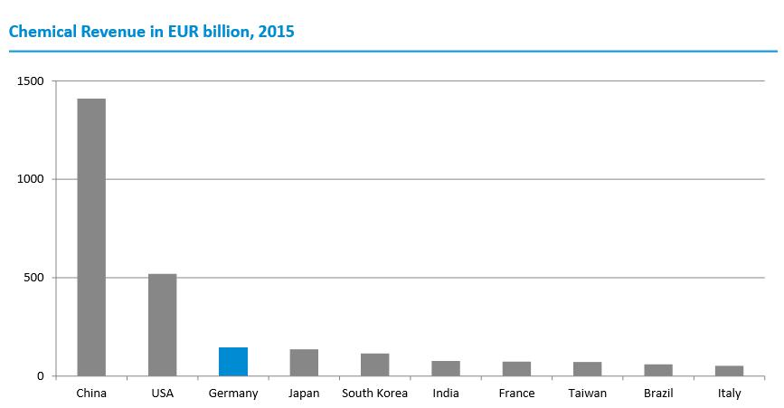

[Source: Cefic, Facts and Figures 2016. Total revenue globally 2015: EUR 3,534 billion; Report on the German Chemical Industry- Germany trade and Invest. Chemdata International, VCI]

4
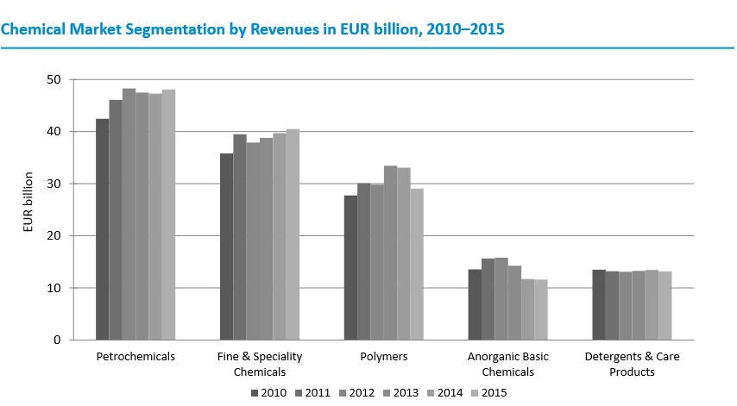

[Source: VCI, Chemiewirtschaft in Zahlen 2016, Report on the German Chemical Industry- Germany trade and Invest]

The industry is “dominated” by small companies, whereas the lion’s share of revenues is raised by large corporations. There were nearly 3,300 chemical companies in Germany in 2013, of which 97% were SMEs (less than 500 employees). The country’s globally renowned and highly innovative “Mittelstand” makes up the backbone of the chemical industry and generates around 30 percent of revenue with approximately one third of the workforce.

2.2. Motivation for Investment

With around 11 percent of total manufacturing industry revenue in 2015, the chemical industry is the fourth-largest industrial sector in Germany after the automotive, mechanical engineering, and metal sectors. The attractiveness of Germany as a production location for the chemical industry is based on specific strengths of innovation, productivity and resource efficiency. This is also based on the presence of strong client industries including the automotive sector. The country’s historical export strength and research environment are also attractive factors for investments. Industry R&D efforts are complemented by institutional R&D. Publicly funded research units of the Max-Planck Society, the Frauenhofer Gesellschaft, the Helmholtz Association, and the Leibniz Association undertake R&D in close cooperation with the industry; often taking place within Germany's unique chemical cluster network infrastructure. The unique combination of industrial and institutional R&D represents an immensely valuable source of capacity for international companies.

Because of market attractiveness, most chemical investments in Europe for the period 2011 to 2015 occurred in Germany.

5
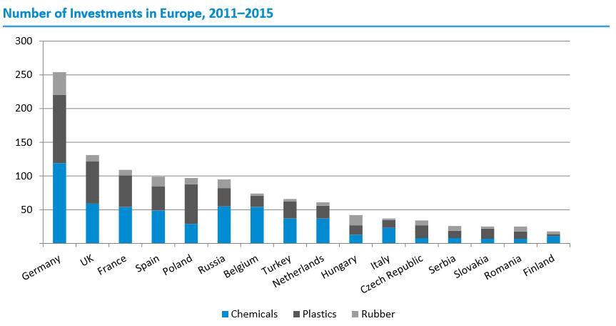

[Source: fDi markets. Anzahl Investitionsvorhaben (1338) (Number of investments): Chemie (651)(Chemicals), (536) (Plastic), (151) (Rubber). 89% of all investments are graphically represented. Report on the German Chemical Industry- Germany trade and Invest]

2.3. Raw materials supply

Germany´s chemical industry regions are well connected to the European pipeline grid. The country’s chemical complexes are served by excellent logistics networks – from road and rail to waterway and pipeline. Investment is being made all the time to improve provision across the existing logistics infrastructure.

2.4. Major international players

World-class company performance is imperative in the face of numerous global challenges. German companies have long been at the forefront in developing innovations and trends and continue to consolidate their global prominence. The country’s top producers account for many globally active chemical companies; being headed up by such illustrious names as BASF, Bayer, Henkel, Evonik, Covestro, Merck, Lanxess, Freudenberg, Wacker, and Altana.

2.5. Chemical industry-specific clusters

The central task of cluster platforms is to connect businesses with each other as well as businesses with research institutions. Chemical Clusters offer added value to their members:

- as networking platform for R&D institutes, companies, and authorities within the region

- through strategic alliances with international chemical sites in Europe, Asia and the US

- by strengthening the cluster members’ global competitiveness

Some of the clusters in the chemical industry located in Bavaria (BY) and Baden-
Württemberg (BW) are:

- Chemie Cluster Bayern

6

- Traegerverein Umwelttechnologie-cluster Bayern e.V

- Bio Lago e.V (BW)

- Process Engineering and Technology Network of Competence Pro3
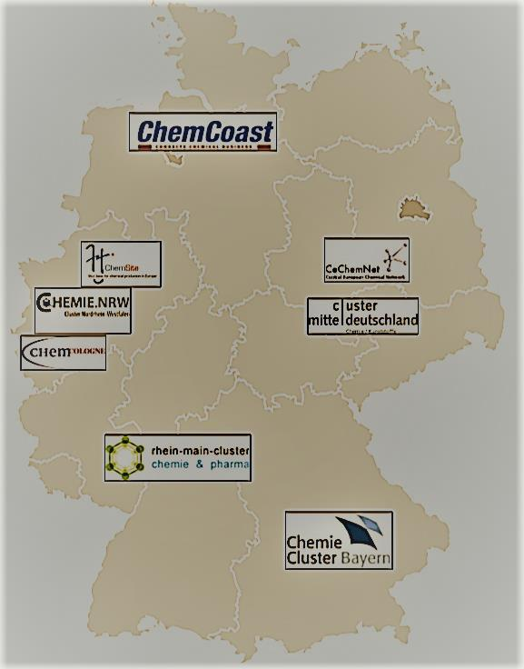

[Source: Report on the German Chemical Industry- Germany trade and Invest]

2.6. Chemical Parks

About 30 chemical parks offer cost efficient and unique benefits through

- Excellent infrastructure

- Chemical raw materials via pipelines

- gases and steam via pipelines

- secure energy supply

Site operators offer expertise and services from one source

Investors choose the services from site operator that suits their business model best.

7
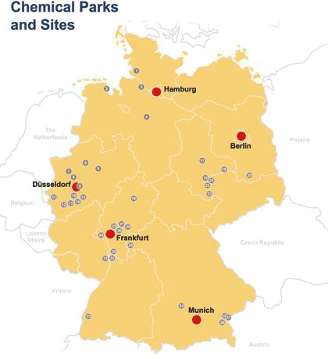

[Source: Factsheet „Chemical Parks in Germany “, Germany Trade & Invest, April 2015; Report on the German Chemical Industry- Germany trade and Invest]

2.7. International Business hub

Germany is home to a number of the world’s most prestigious chemicals, plastics and rubber industry trade fairs, making Germany an internationally leading business hub in the chemical industry. As well as providing excellent business opportunities, visitors also have the chance to learn more about the latest state-of-the-art innovations and developments in the sector. Important shows include:

8
 |  |  | Number of | Number
# | Trade Fair | Cycle | Number of | of | Description
 |  |  | Exhibitors | Visitors
 |  |  |  |  | The product spectrum at the
 |  |  |  |  | European |  | Coatings |  |  | Show
 |  |  |  |  | reflects the innovations in paint
 |  |  |  |  | and coatings. Every two years,
 | European |  |  |  | the | formulators |  |  | of | paint,
 | European |  |  |  | coatings, |  | adhesives |  |  |  | and
 | Coatings |  |  |  |  |  |  |  |  |  | and
1 | Coatings | Biennial | 1135 | 30198 | sealants, producer of additives,
1 | Show,
 | Show, |  |  |  | producer |  | of |  | construction
 | Nuremberg |  |  |  |  |  | of
 | Nuremberg |  |  |  | chemical |  | products, |  |  | industrial
 |  |  |  |  | processors |  | and | representatives
 |  |  |  |  | from | science |  | and |  | research
 |  |  |  |  | discuss the latest developments
 |  |  |  |  | in the coatings industry.
 |  |  |  |  | Analytica is the world's largest
2 | Analytica, | Biennial | 1244 | 35002 | trade | fair for the analysis,
2 | Munich | Biennial | 1244 | 35002 | laboratory-technology |  |  |  |  |  | and
 |  |  |  |  | biotechnology sectors
 |  |  |  |  | Chemspec |  | Europe |  | is | Europe’s
 | Chemspec, |  |  |  | premier |  | sourcing |  |  |  | and
3 | Cologne (in | Annual | 401 | 6476 | networking |  | event |  | for | the | fine
 | 2018) |  |  |  | and | speciality |  |  | chemicals
 |  |  |  |  | industry.
 |  |  |  |  | COMPOSITES EUROPE is
 |  |  |  |  | established as an international
 | Composites |  |  |  | business platform for the
4 | Europe, | Annual | 406 | 8342 | composite industry. New modules
 | Stuttgart |  |  |  | facilitate the matchmaking and
 |  |  |  |  | generate new business for the
 |  |  |  |  | exhibitors.
 | K, |  |  |  | The trade fair for the plastics and
5 | K, | Triennial | 3293 | 232053 | rubber industry that is still the
5 | Dusseldorf
 | Dusseldorf |  |  |  | leading event for this sector today
6 | Achema, | Triennial | 3800 | 128888 | World Forum and Leading Show
6 | Frankfurt | Triennial | 3800 | 128888 | for the Process Industries

2.8. Germany’s chemical exports

Germany’s chemical industry exports around the globe. In 2015, more than 70 percent of German exports remained within Europe, while 12% and 10% were exported to Asia and North America (NAFTA) respectively. The four largest export destinations in EU were:

- France (EUR 9.7 billion)
- The Netherlands (EUR 7.8 billion)
- Italy (EUR 7.2 billion)
- Belgium (EUR 6.8 billion)

By far the most important export countries outside Europe are the US (EUR 6.5 billion) and China (EUR 4.6 billion)

9
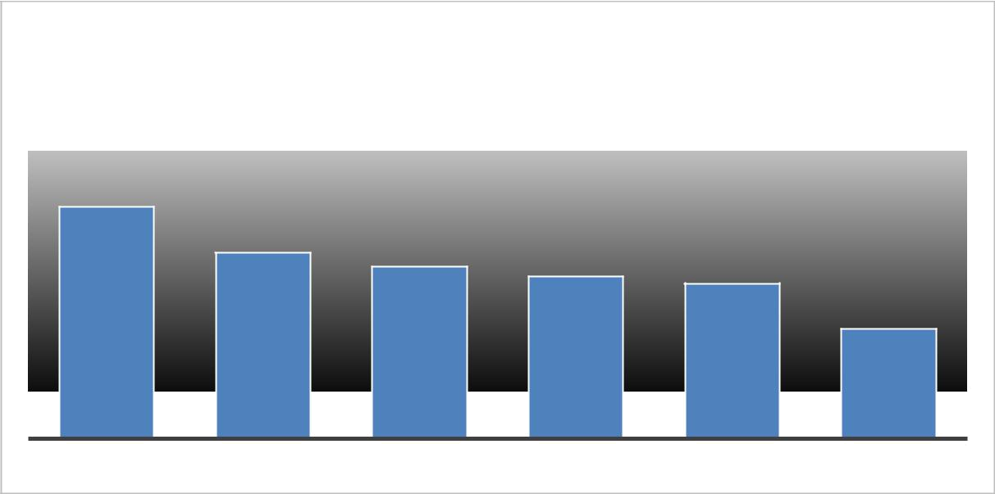

Germany's chemical exports
in millions [EUR]

9,7
7,8 | 7,2 | 6,8
 | 7,2 | 6,8 | 6,5
 |  |  | 4,6

FRANCE NETHERLANDS ITALY BELGIUM USA CHINA

[Source: Report on the German Chemical Industry- Germany trade and Invest]

- Chemical Industry in India

Chemical industry is one of the fastest growing industries in India. At the same time, it is also one of the oldest domestic industries of India which started working soon after India's independence in 1947.

The chemicals industry of India contributes 2.1% towards the nation’s gross domestic product (GDP) and accounts for 15.95% of India’s manufacturing sector. This Industry is an important contributor to the Indian economy sustaining a variety of downstream industries such as textiles and pharmaceuticals. India is currently the 6th largest producer of chemicals in the world by sales value with combined chemicals sales worth of US$ 93 billion in 2015. It accounts for 2.2% of global share.
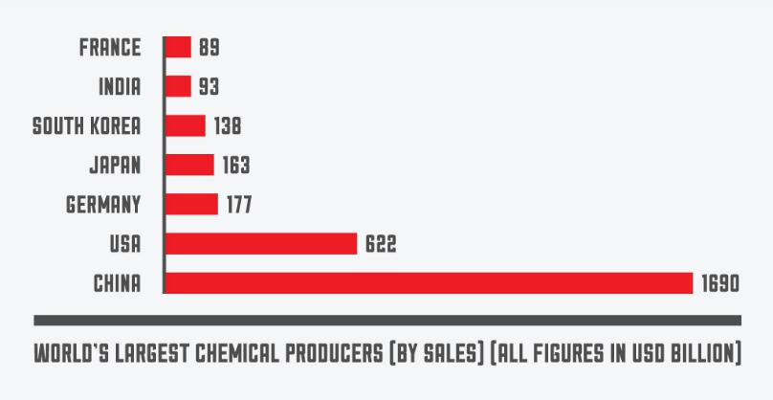

[Sources: Annual report 2015-16, Department of Chemicals and Petrochemicals, Ministry of Chemicals and Fertilizers, Government of India; Make in India report on Chemicals]

India’s production of major chemicals stood at 9,632 thousand MT in 2014-15 with alkali and organic chemicals constituting more than 86% of production and 11,594

10

thousand MT for major petrochemicals production with polymer constituting around 57%. Indian export of chemicals and petrochemicals stood at US$ 27.43 billion in 2014-15 and constituted 9.4% towards total export.
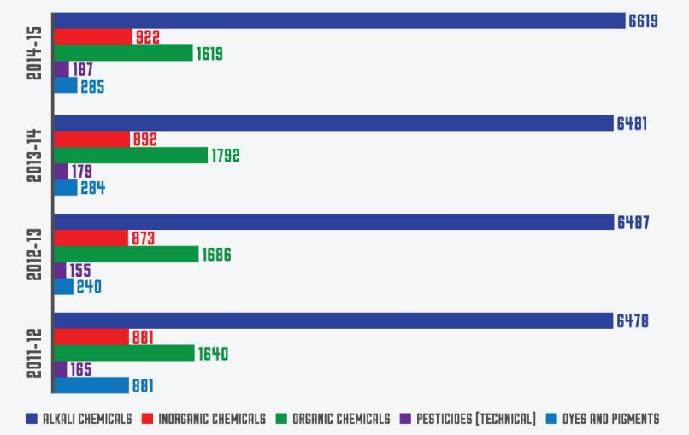

[Source: CEFIC, The European Chemical Industry Council, Facts and Figures, Annual report 2015-16, Department of Chemicals and Petrochemicals, Ministry of Chemicals and Fertilizers, Government of India; Make in India report on Chemicals]

Alkali chemicals form the highest chunk in the total chemical production in India. During FY10, alkali chemicals production (till February 2009) was 5.5 MMT and accounted for around 71% of the total chemical production. The dyestuff sector is one of the important segments of the Indian chemical industry and has forward and backward linkages with a variety of sectors such as textiles, leather, paper, plastics, printing inks and foodstuffs. The textile industry accounts for 70% of the consumption of dyestuffs.

Salient features of exports from India:

- Agro-Chemicals

  - India exports about 50% of its current production and exports are likely to remain a key component of the industry

- Speciality Chemicals

  - The specialty chemicals market has witnessed a growth of 14% in the last five years; the market size is expected to reach USD 70 Billion by 2020.

- India is currently the world’s third largest consumer of polymers and growth in plastic demand will drive up consumption further.

  - Growth drivers include a growing construction industry and adoption of advanced coating, ceiling and polymer-based reinforcing material in construction as well as plastics, paints and coating for the automotive sector.

- Colourant Chemicals

  - The Indian colorant industry is valued at USD 6.8 Billion, with exports accounting for nearly 75%.

11
- India accounts for 15% of global industry share and this figure is expected
to further increase.

- Other segments include petrochemicals, bio-pharma, bio-agri, and bio-industrial products.

3.1. Data on exports and imports

India’s export and import data can be summarised as below:
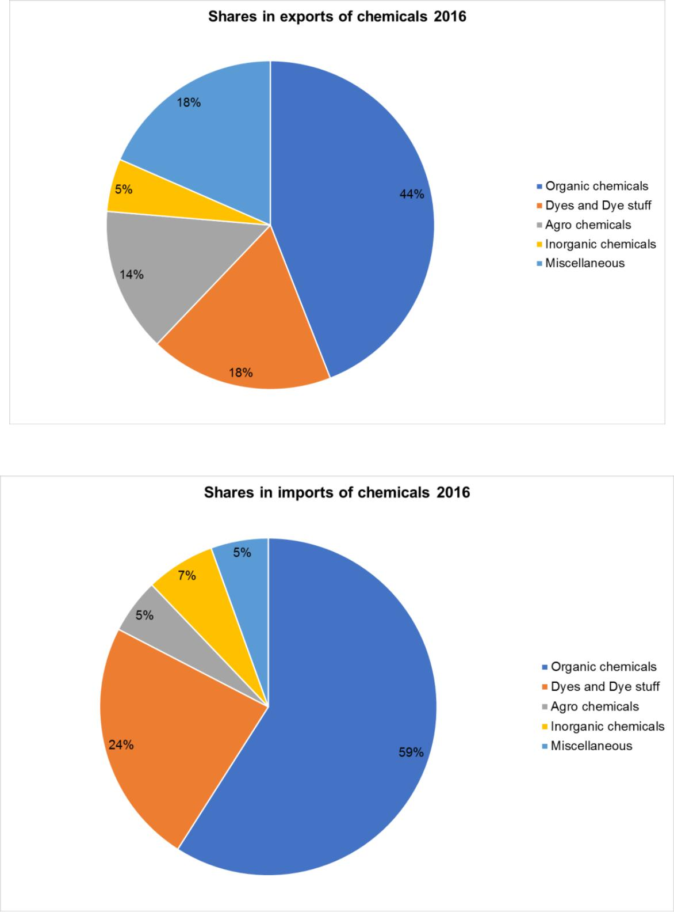

[Source: Ministry of Commerce, India; TechSci Research]

12
- Indo-German Trade

Indo-German trade spans over 500 years and is the basis for strong economic and business ties between the countries. Over the past 55 years, Germany and India have emerged as strong partners for each other. Germany continues to be India’s largest trading partner in the European Union and ranks 4th in the list of India’s top ten trading partners worldwide.

In 2016, Machinery, Electro-technology and Chemical products were India’s highest imported products from Germany.

Indian textiles, chemicals and leather products continue to be the most sought-after products in Germany, emerging as the top three exports to Germany in 2016.

In the period of January 2017 until June 2017, the total volume of trade between the two countries has been:

- Germany’s exports to India – EUR 5301.41 million

- Germany’s imports from India – EUR 4369.74 million
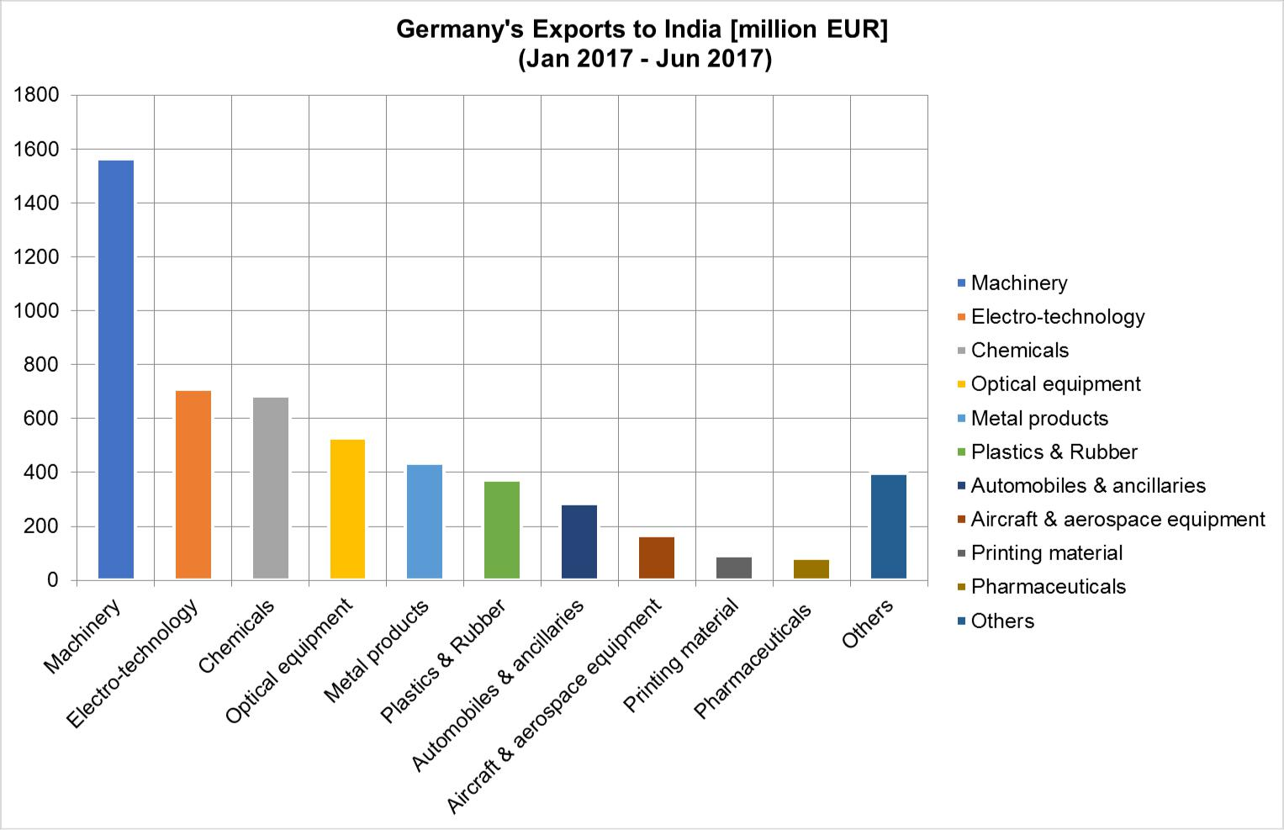

13
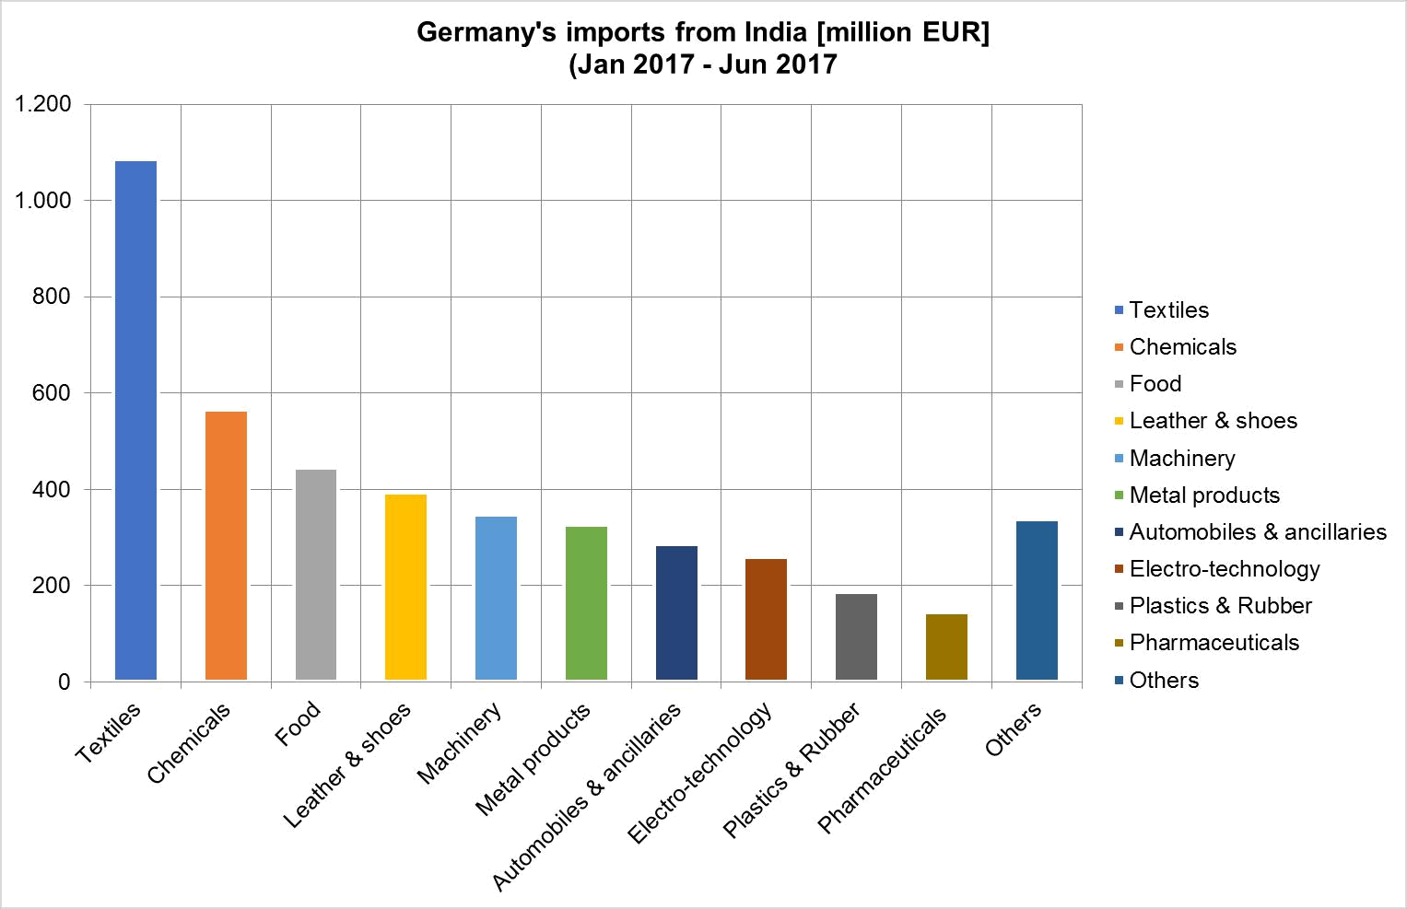

[Source: Federal Statistical Office, Wiesbaden, Annual Review 2017-Indo-German Chamber of commerce]

- Challenges and Opportunities

Indian chemical industry is expected to register a growth of 8-9% in the next decade and is expected to double its share in global chemical industry to 5-6% by 2021. Indian Chemical industry has the potential to grow significantly provided some of the key growth imperatives are taken care of. Securing Feedstock, Right Product Mix, M&A opportunities are currently the key imperatives for chemical industry in India.

India’s exports of chemicals is largely dependent on the performance of the organic chemicals category that include products such as acetic acid, acetic anhydride, acetone, phenol, methanol, formaldehyde, nitro benzene, citric acid, aniline, acetaldehyde, ethanolamine, and ethyl acetate. U.S.A, China, Germany and Pakistan are the top destinations for India’s organic chemical exports and continue to show a positive trend

[Source: Federal Statistical Office, Wiesbaden; Annual Review 2017-Indo-German Chamber of commerce]

Considering the imports of chemicals required by the German chemical industry from various countries, the import value indicated in the chart below represents the theoretical maximum potential for volume of business in the specific areas mentioned.

14
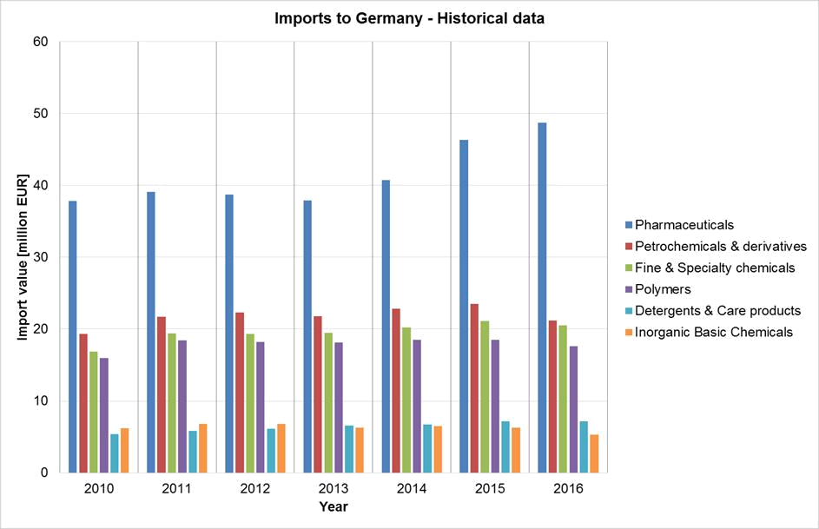

[Source: Statista-The statistics Portal, https://www.statista.com/]

This business potential may be realised by Indian exporters who could make inroads into Germany by using the opportunities in the sectors mentioned below.

- In Pharmaceuticals sector, India accounts for 20% of global exports in generics, making it the largest provider of generic medicines globally. India is expected to rank amongst the top three pharmaceutical markets in terms of incremental growth by 2020. Indian pharma industry should lay its emphasis in the development of infrastructure for conducting more R&D activities of international standards. Stronger patent laws can help export driven industrialisation boost.

- Growing at a compounded annual growth rate(CAGR) of about 14%, petrochemicals Industry in India is likely to reach USD 100 billion by 2020 from the current size of about USD 40 billion. India’s high inflation rate and rising prices, weakening business and consumer sentiment and the complicated access to lending pose a greater threat to petrochemical sector. Raw materials are difficult to procure and expensive due to the lack of adequate facilities at ports and railways. Many manufacturing plants need to be upgraded and made more environmentally friendly. India is gifted with coal in abundance. Coal gasification comes as the perfect opportunity for the Indian chemical industry to increase its petrochemical and chemical production by leveraging in gasification technology.

- India's speciality chemicals industry is valued at about $25 billion, has successfully delivered 13 per cent growth over the past five years, primarily led by domestic consumption. Currently the domestic specialty chemical

15

producers also face challenges related to feedstock availability, higher operational costs, outdated technology/ process, limited investment in R&D & a negative perception amongst end consumers. Apart from depending on regulatory interventions, Indian players should come together and proactively work towards collaborative investment to avert global competition. More investment in Research and development can help attract alliances/collaboration with global firms to jointly manufacture speciality chemicals in the country. The Government of India can help in boosting the sector by initiatives in developing new industrial areas, in simplifying the business climate by speeding up licensing procedures, and industry-friendly norms for pollution, in enhancing the industry’s global outreach by bringing out favourable Import policy and provide proper guidelines for exports with better incentives and by rationalising various taxes and simplifying it to a single window tax system.

- Indian polymer additives market has been growing at a CAGR of 10%-12% in the last five years. Some of the growth drivers in this industry are

    - growth in end-use industries: Increasing growth in plastic demand due to higher usage in packaging, construction and automotive sectors.

    - Low per capita consumption: Per capita consumption of plastic is only 5 kg in India where as it stands at 90 kg in North America, 65 kg in West Europe and 12 kg in China.

    - New applications: Increasing environmental concerns and cost considerations leading to replacement of wood, metals and glass by plastic in various applications.

- The Indian personal care ingredients market stood at $ 485 Mn in 2012. Actives and inactive ingredients account for 40% and 60% by value of the total personal care ingredients market respectively. In India, UV ingredients and conditioning agents have a mature market while Anti-aging agents and exfoliators are in growth phase. Active ingredients such as anti-ageing ingredients, exfoliators, conditioning agents are the ones providing the final property to the product. There are not many manufacturers for the same in India and most of the active ingredients are being imported. There are multiple and complex regulations under different bodies due to which there is a lack in implementation of set guidelines and laws. There is an also non-uniform licensing approval across states. This leads to inconsistent approach across authorities in interpretation of a particular issue. The demand for personal care ingredients is expected to be driven by two major factors:

  - Rising demand for personal care products due to growing population and increasing per capita income.

  - Increasing personal care ingredient usage in formulation: Demand for products with higher/ better performance.
  - Increasing demand for multi-functional personal-care products

  - Growing global demand for green products giving rise to huge exports potential.
  - Men's grooming is another emerging segment which is picking up fast.

  - The rich heritage of Ayurveda is expected to make India a hub for natural ingredients.

16

  - India has a long standing, well established inorganic chemical industry that produces a range of chemicals to support the country’s thriving manufacturing sector. All the key alkaline chemicals and basic inorganic chemicals are growing in the domestic and exports markets. Lack of world class infrastructure, lack of cheaper raw material availability, lack of uninterrupted supply of power and low capacity utilisation are some of the problems faced by this sector. Use of alternative feedstock, actively pursue the coal to chemical process to ramp up manufacturing capacities are some of the opportunities available in this sector.

- Summary:

- Germany is the world’s third largest chemical market, being surpassed only by
China and USA in terms of revenues.

- The attractiveness of Germany as a production location for the chemical industry is based on specific strengths of innovation and research environment, productivity and resource efficiency.

- Germany’s chemical complexes are served by excellent logistics networks – from road and rail to waterway and pipeline.

- Chemical clusters and chemical parks have helped Germany to strengthen its position in the chemical market.

- Numerous trade fairs in the chemical sector in Germany providing excellent business opportunities for Indian exporters. Visitors also have the chance to learn more about the latest state-of-the-art innovations and developments in the sector.

- Chemical Industry is an important contributor to the Indian economy sustaining a variety of downstream industries such as textiles and pharmaceuticals.

- Indian textiles, chemicals and leather products continue to be the most sought-after products in Germany, emerging as the top three exports to Germany in 2016.

- India’s exports of chemicals is largely dependent on the performance of the organic chemicals.

- Germany is one of the top destinations for India’s organic chemical exports and continue to show a positive trend.

- In order to be more competitive at a global level, India will have to address the key issues pertaining to inadequate infrastructure and lack of availability of low cost feedstock for production. The Industry can leverage new technologies and explore alternative feedstock options such as coal gasification and pet coke to mitigate the issue of feedstock availability in this

sector

11. Immense opportunities for growth exists in the fields of specialty chemicals, polymers and agrochemicals industries as ‘Make in India’ initiative further facilitates growth and investment.

17
- References

  - IBEF report on Chemicals, ( https://www.ibef.org/download/Chemicals-November-2016.pdf )
  - IBEF report on “Developing a greener future”

  - Planning commission document on five-year plan, 2012-17, for Indian Chemical industry (http://planningcommission.gov.in/aboutus/committee/wrkgrp12/wg_chem0203

.pdf )
  - Statista-The statistics Portal, ( https://www.statista.com/ )
  - FICCI report on India Chemicals 2013
  - FICCI report on India Chemicals 2016
  - IBEF report- Inorganic Chemicals- Market and opportunities.
  - Chemical Industry overview- Resurgent India

  - Report on the German Chemical Industry- Germany trade and Invest (http://www.gtai.de/GTAI/Navigation/EN/Invest/Industries/chemicals )

  - Federal Statistical Office, Wiesbaden; Annual Review 2017-Indo-German Chamber of commerce

  - Make in India report on Chemicals and Petro chemicals (http://www.makeinindia.com/sector/chemicals )

  - Ministry of Commerce, India, ( http://www.commerce.gov.in/ )

  - TechSci Research ( https://www.techsciresearch.com/ )

  - TATA strategic Management Group ( https://www.tsmg.com/insights/chemical-ins.html )

  - CEFIC, The European Chemical Industry Council, Facts and Figures (http://www.cefic.org/Facts-and-Figures/Chemicals-Industry-Profile/ )

  - Annual report 2015-16, Department of Chemicals and Petrochemicals (http://chemicals.nic.in/ )
  - Ministry of Chemicals and Fertilizers, Government of India
(http://www.fert.nic.in/)
  - IndiaChem Report 2013 ( http://indiachem.in/ )

  - IndiaChem report 2012 ( http://indiachem.in/ )

18
Disclaimer

The information and data contained in this report have been checked and verified from published sources. In case any error or discrepancy is noted, it may be brought to the attention of Consulate General of India, Munich. The information contained in the report is purely for the purpose of reference.

Contact for queries:

Consulate General of India

Commercial & Economic Wing Mr. Asheesh Gupta, Consul (E & C) Ms. Seema Sudarshan, Assistant – Commercial Wing Widenmayerstrasse 15, 80538 Munich, Germany Email: com.munich@mea.gov.in

Web: www.cgimunich.com
Facebook: https://www.facebook.com/ConsulateGeneralofIndiaMunichGermany


http://www.makeinindia.com/

Consulate General of India
Munich

19


20

